1. . Consolidate Datasets: - Combine the four datasets (Employee Details, Project Assignments, Attendance Records, and Training Programs) into a centralized MySQL database.
   1. Done below as techsphere_database

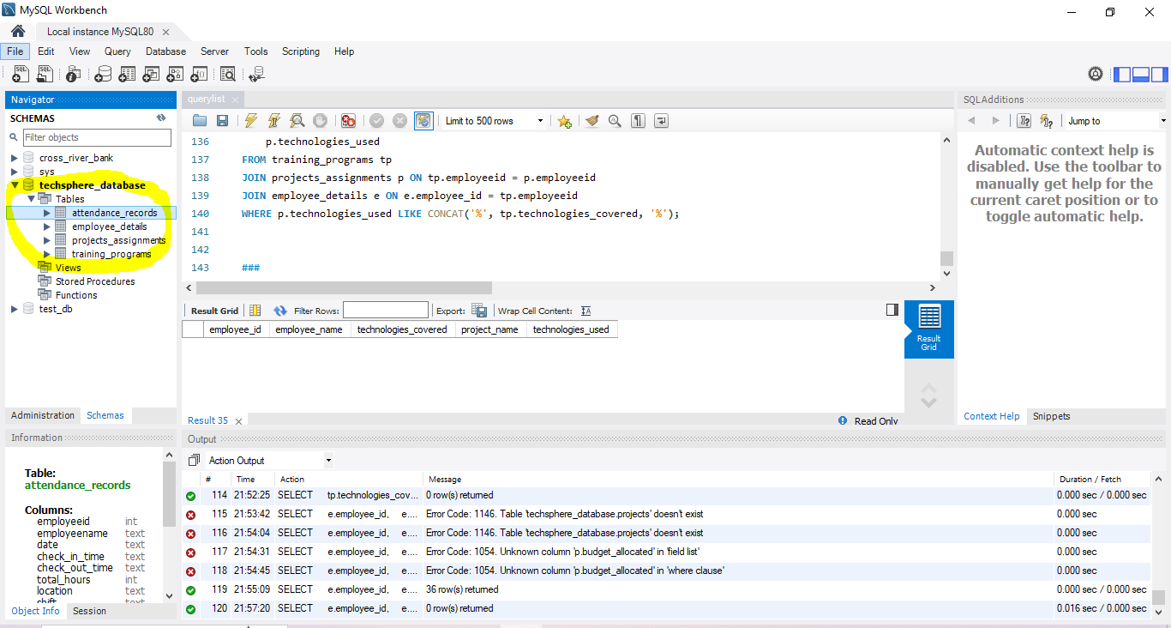

1. Add Mapping for Training Programs: - Use logical mapping to add employee_id to the Training Programs dataset by matching department_id and employee_name from the Employee Details dataset. Completed Below(2)
2. Schema Design: - Create a relational schema with the following tables: - Employee_Details: Contains core employee information. - Project_Assignments: Tracks projects and employee contributions. - Attendance_Records: Logs employee attendance data. - Training_Programs: Details of training sessions and feedback scores.- Completed Below

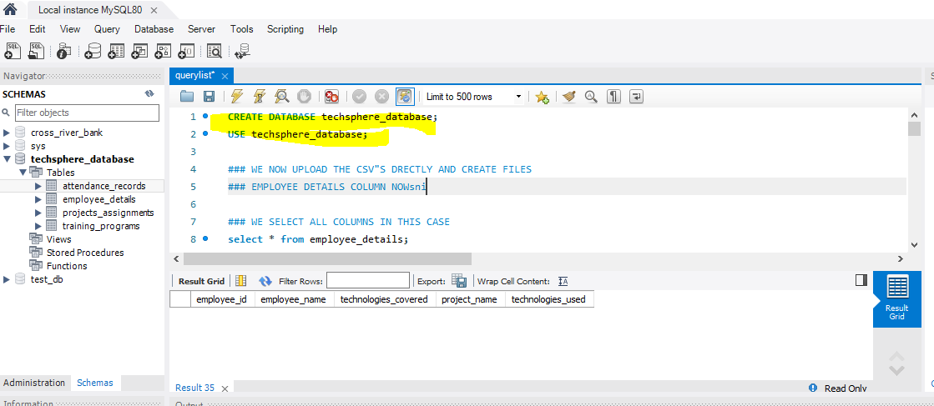

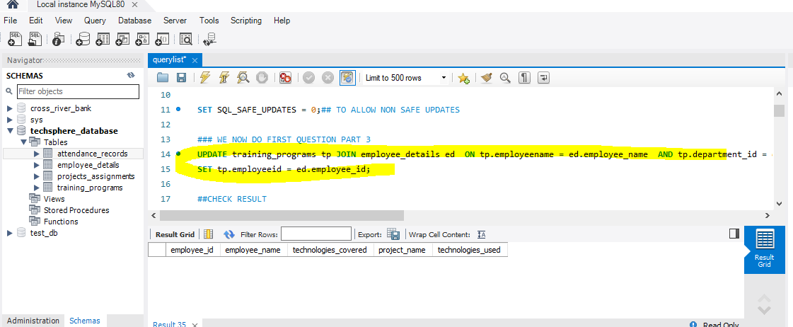

(2)

1. 1. Employee Productivity Analysis: Identify employees with the highest total hours worked and least absenteeism.

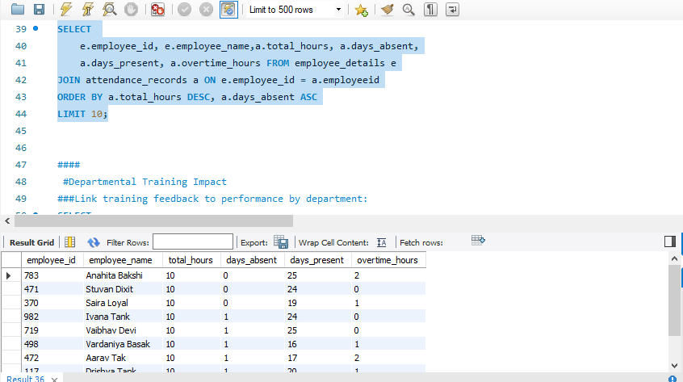

1. Departmental Training Impact: - Analyze how training programs improve departmental performance.

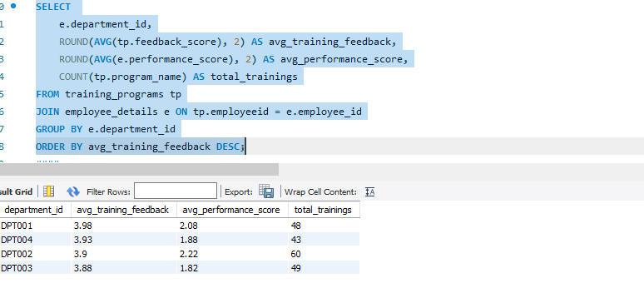

1. .Project Budget Efficiency: - Evaluate the efficiency of project budgets by calculating costs per hour worked.

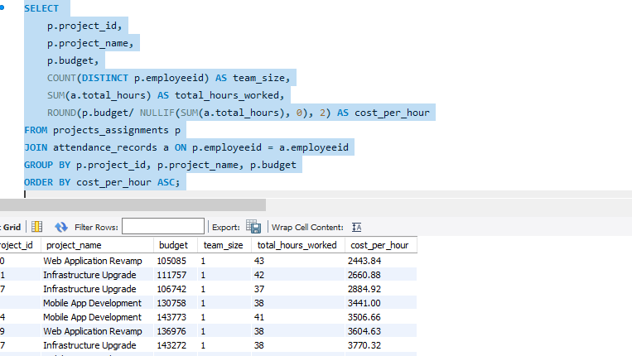

1. Attendance Consistency: - Measure attendance trends and identify departments with significant deviations.

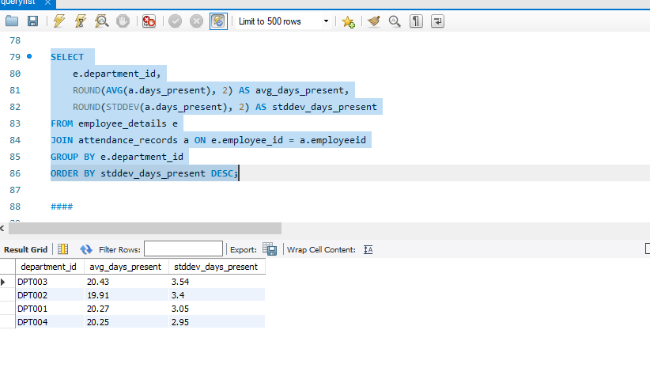

1. Training and Project Success Correlation: - Link training technologies with project milestones to assess the real-world impact of training.

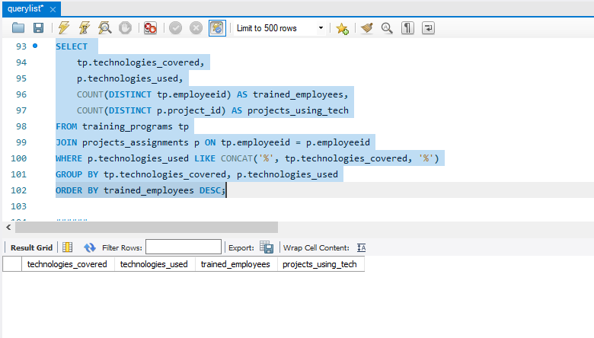

1. High-Impact Employees: - Identify employees who significantly contribute to high-budget projects while maintaining excellent performance scores.

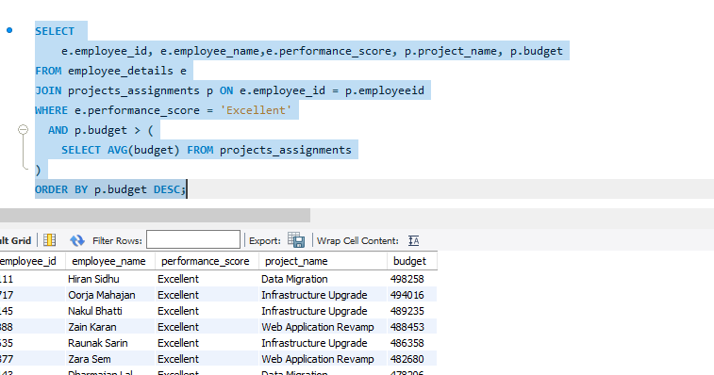

7. Cross Analysis of Training and Project Success - Identify employees who have undergone training in specific technologies and contributed to high performing projects using those technologies.